Small Business Acquisition | Team Project Instructions

Background & General Details
Your team has been hired by a business that needs your advice. (See Asset List.) This project has several components:
- Team leader should submit Law Firm name to your professor via email by _________.
- A list of firms will be posted on Canvas on _____ which will include who you represent.
- Meet with managing partner outside of class on or before ________.
- Each Acquisition Agreement Drafting Firm must send their acquisition agreement to opposing counsel via email cc your professor no later than ________.
- Negotiation of a business acquisition/sale (Taking Place on _______)
- Next steps client email, peer eval, acquisition agreement (via dropboxes due ________).
Each Acquisition Agreement Drafting Firm—team of “attorneys”—must create a law firm “name.” During this phase, only one member of each team—team leader—can contact your professor with questions and that member is responsible for disseminating the Acquisition Agreement to opposing counsel. A team leader must be selected and then must email your professor that they are the team leader together with the law firm’s name by the aforementioned deadline.
This is a collaborative assignment. You are not permitted to consult with anyone other than your law firm members. You will find additional research to be helpful with this assignment.
For purposes of this assignment, your client is organized and physically located in _______. Your client does not do business outside of ________. The owners and purchasers live within _____.
Client Interview
During class on ______, you will be partaking in your group client interview. Sellers and Purchasers (as a group) will meet with their client via Zoom. The client will tell their story and then you may ask questions.
Initial Managing Partner Meeting
During class on ______, you will meet your managing partner. During this meeting your partner is going to:
- help you establish a game plan for creating the acquisition agreement;
- help you create a timeline for the project; and,
- advise you on related matters such as negotiating techniques.

Acquisition Agreement
Your firm is to produce a complete draft Acquisition Agreement containing provisions your client wants to see. While you will need to come up with a price, you do not need to assign allocations to specific assets or groups of assets. We will leave that to the accountants.
Each firm must set up a 15-minute meeting with your managing partner at which time you may ask them to review one section of your agreement. You may also ask your managing partner questions. This meeting must have taken place prior to _________ and all firm members must be present.
You will then exchange agreements with opposing counsel. Seeing the other side’s proposed agreement will enlighten you as to what the other side wants, which will help you plan out your negotiation.
Remember this is a small deal so it should not require volumes of information in the agreement. However, the agreement does need to encapsulate the entire transaction and protect your client. The expectation is that all law firm members work together. You are each responsible for the entire agreement and process.
Agreement Formatting Details
- Your agreement must be 2,000 words or less.
- Utilize appropriate headings for organizational purposes.
- Number your sections and subsections as such:
SECTION 1: [insert title]
  - [insert title]
  - [insert title]
- Use page numbers.
- Do not use a font size smaller than 12-point.
- There should be no signatures on the document, but you need to have appropriate signature lines.
Negotiation
You will engage in an in-person negotiation recorded with a laptop connected to Zoom. It is expected that each member of the team engages as equally as possible in these negotiations. After your negotiation is over, one of the seller’s attorneys from the negotiation team will upload the zoom link to the Canvas dropbox by the end of that day.
You should research negotiating techniques. Remember you have to find a way to close this deal in the time allotted. There will be no extensions allowed. Also, be mindful of balancing your client’s needs and preferences with coming to a compromise and closing the deal.
At a minimum, your negotiations must produce an understanding of the following:
- Confidentiality
- Type of acquisition (asset or entire business)
- Overall price to be paid (in order to be convincing, you should be prepared to justify the price)
- Employee retention
- Representations and warranties
- Indemnification
Email to Client and Acquisition Agreement
Each Negotiation Group (comprised of the negotiation team for the seller and the purchaser) will draft a final Acquisition Agreement that reflects the results from your negotiation. Use the same formatting instructions as applicable to the draft. You may use either the Seller’s or Purchaser’s draft Acquisition Agreement as your starting point, or parts of each, but be sure that the Negotiation Group is putting together a cohesive document for your clients to execute. This part of the assignment is collaborative among the members of the Negotiation Group.
Next you will produce an email that will serve as the vehicle to attach your Acquisition Agreement. The email should also outline next steps for the client and any instructions you have for the client relative to closing. Additionally, inform your client how certain sections in the agreement will protect it/them. This part of the assignment is collaborative among you and the person you negotiated with.
For the email, you may use the original name of your firm.
Peer Evaluations
In order for a team collaboration to work effectively, each member must contribute equally, and each must truly collaborate on the entire project. This means that the team members have meetings and discussions, not simply divide the work. Each student will be required to complete a peer evaluation for each member of the law firm team. Your evaluation should be candid, professional, and fair. The evaluation will not be shared with other members of your team or group.
Additionally, each member will be required to peer evaluate the team it negotiated against.
Questions for the peer evaluations will be posted on Canvas.
The results of the evaluations could impact a member’s professionalism grade.
Grading
This assignment is graded, and you are responsible for the project in its entirety. This means that if you make the unfortunate decision to parse the assignment rather than work on it together, you are responsible for any and all errors your teammates make. Everyone on the team will receive the same grade except for any student who does not adequately participate. This assignment is worth 30% of your overall grade for the course.
Miscellaneous
You will not be doing a letter of intent for this exercise. However, throughout the process consider whether you think a letter of intent would have been helpful.
Canvas Chart Explanation
ACQUISITION AGREEMENT DRAFTING FIRM
(students collaborate to create firm name and draft AA)
(students collectively meet with the managing partner and client)
Negotiation Group
(students create final version of AA after negotiation)
Neg. Team for Seller  (students create client email) | Neg. Team for Purchaser  (students create client email)

The Project Timeline

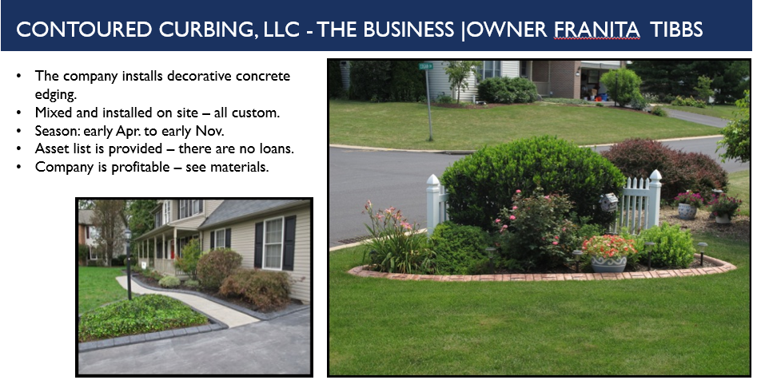

Contoured Curbing, LLC – Asset List
Marketing Materials

- Company advertising postcards and brochures
- Yard signs & info tubes
- Digital photos of jobs
- Workers’ shirts and decals
- Home show display materials
    - Backdrop
    - Table
    - Concrete samples and display
    - Posters
    - Slide Show
    - Card & Brochure holder
    - Grass carpet

Office & Business/Goodwill

- $20,500 in outstanding pre-orders that were promised priority installation at the beginning of 2024 season
- Custom programmed Filemaker database with 1,151 customers, various reports, address label capabilities, invoicing, accounting, etc.
- Facebook page (2000+ followers)
- Company website+ personalized company email addresses
- Logo
- Phone number
- Concrete Samples
- Estimate Form (fillable .pdf)
- Printable stickers for postcards
- List of Vendors/Suppliers
- Color Estimator Spreadsheet
- Contact list for home show, advertising, etc.
- Quickbooks online - payroll (probably can transfer)
- PA Home Improvement Contractor number and EIN

Equipment
- 2017 FORD F-350 Diesel dually King Ranch truck (has logo and PAHIC number on it)
- Trailer with new mixer drum, hose holder, reinforced door locks
- Bed Edger
- Curb Extruding Machine
- Moulds with accompanying trowels
- Design equipment - Stamps, rollers and skins
- Sidewalk making stuff (mould, rubber and metal stamps, trowels)
- Hoses
- Wheelbarrows
- Small Tools (cable cutters, +various)
- Sealant sprayer
- Tarps
- Leafblower
- Weedwacker
- Pressure washer + warranty

Inventory/Supplies

- Integral Color (various amounts of different colors - over 650 lbs)
- Sealant
- Cable
- Release Powder (various amounts of 5 different colors - about 70 lbs)
- Fiber

Storage
- Table
- Scale
- Bins and Containers
- Shelving

Financial Notes
 | Revenue | Gross Profit
2018 | $51,000 | $25,780
2019 | $135,000 | $80,244
2020 | $65,000 | $30,000
2021 | $142,000 | $115,000
2022 | $172,000 | $145,000
2023 | $174,000 | $150,900

2018
First full year. No print ads until late summer. Advertising was 2 home shows. No reseals. Website not high on the search engines yet. No social media used.
2019
Late summer/fall print ads. 3 home shows. Lots of reseals with our customers. Bought a defunct company’s customer list and there were a lot of reseals for those customers. Website moved up on the search engines. Started a referral bonus which generated more business.
2020
Pandemic caused issues with having employees working together even if they were outside. Customer uncertainty. Still managed a profitable season albeit it less than other more recent years.
2021
Pandemic still loomed but people were ready to get work done. Hired more people this season to cover the increase in jobs. Larger jobs yielded higher profit margins.
2022

Print ads started in spring. 2 home shows. Print ad strategy changed and encouraged low footage jobs. Expanded into two other counties.
2023
Print ads started in spring (spring and fall). Changed ad to entice larger sized jobs by offering discount. This worked. Expanded into another county. Scaled back to one main employee +1 other employee. The main employee did some jobs by himself which increased profit margin even though we gave him a bonus for working alone.

